Phần 1: Một số lệnh Docker Compose cơ bản
1. docker compose version
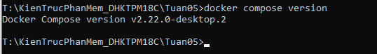
2. docker compose up
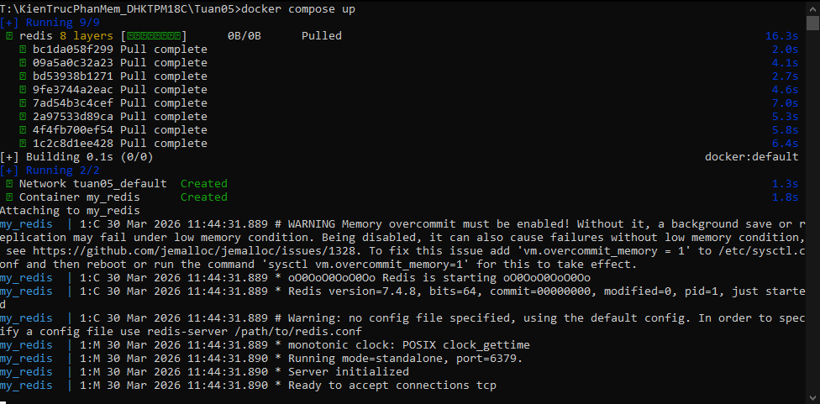
3. docker compose up –d
4. docker compose ps
5. docker compose down
6. docker compose restart
7. docker compose logs –f
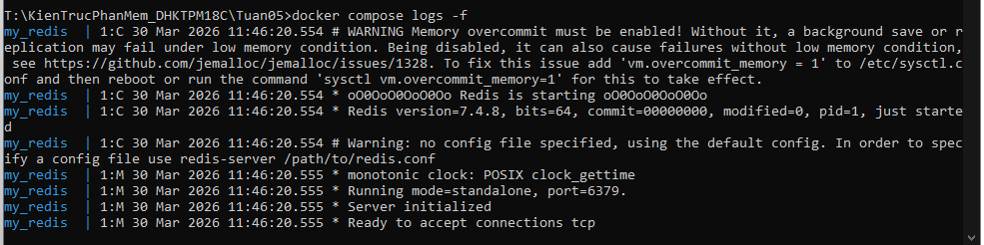
8. docker compose build
9. docker compose exec <service_name> <command>
10. docker compose down –v
11. docker compose run <service_name> <command>
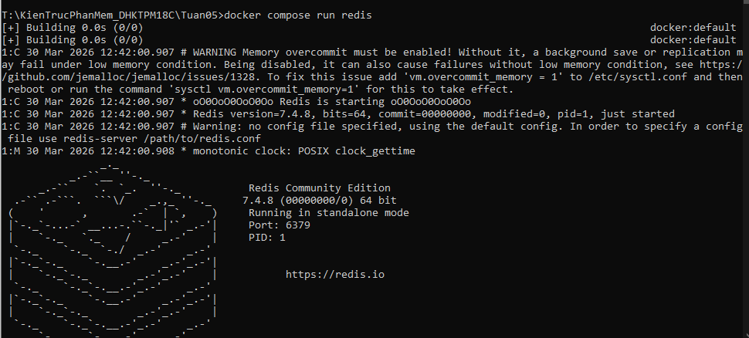
12. docker compose stop <service_name>
13. docker compose rm <service_name>
14. docker compose config
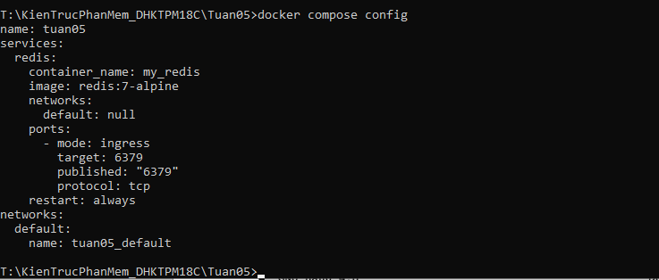
15. docker compose up -d –build
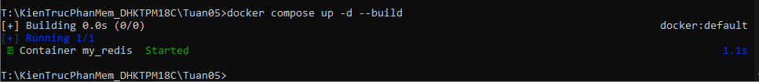
Phần 2: Docker Compose file

